**Instructions:**Replace **[bracketed red text]** with the requested information or screen capture.  
Replace **bracketed red text with black text**.  
**PLEASE do not include full page, full window screen shot images**, or full screen shots that have been reduced in size.   
Use a snippet tool to capture parts of the screen and insert those images into the template.  
**Do not remove tags from this template. An example of a tag is [C01]. All fields are required.***Please do not alter template formatting or delete parts of this template.*

Part A - Student Information:   
 **1. Student Name: Brian Salinas**

**2. Class Designation: IN-CLASS**

**3. Did you complete the activity before starting this assignment? YES**

**4. Did you work with any other students on this assignment? NO**Part B –CMS Webhost Information:

**1. Which web host did you use for this assignment, Shared web-host SiteGround (another shared web host) or Pantheon or Cloud web development environment?**

**SiteGround**

Part D – Drupal 8 Site Configuration

Drupal 8 Screen Captures:

1. SCREEN CAPTURE – Backend Account Settings, REGISTRATION AND CANCELLATION  
   Admin toolbar > Configuration > Account settings, Registration and Cancelation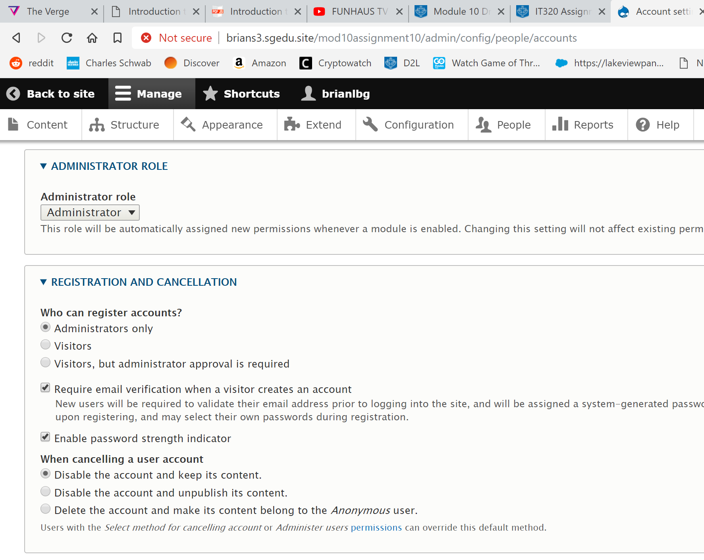 [D01]
2. SCREEN CAPTURE – Backend Appearance  
   Admin toolbar > Appearance showing the Default client facing-theme 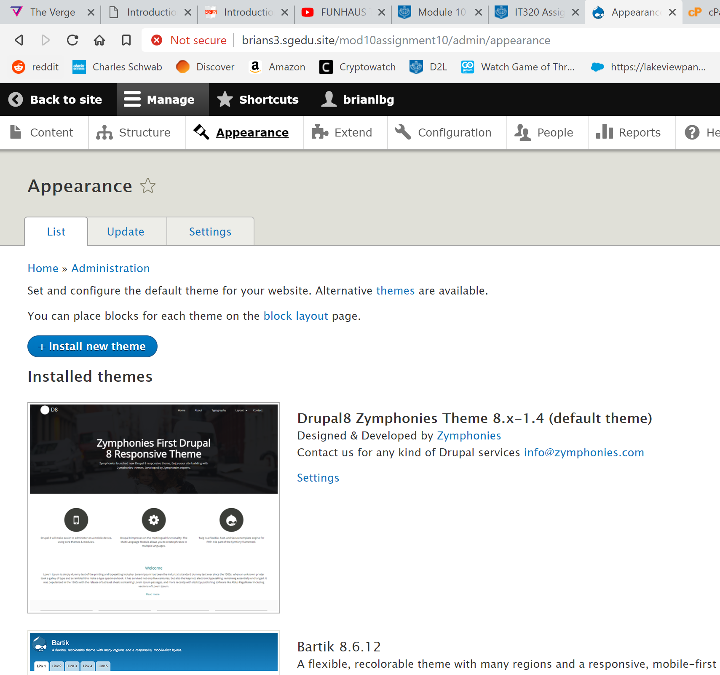 [D02]
3. SCREEN CAPTURE – Backend Appearance  
   Admin toolbar > Appearance showing the Bootstrap 3 theme 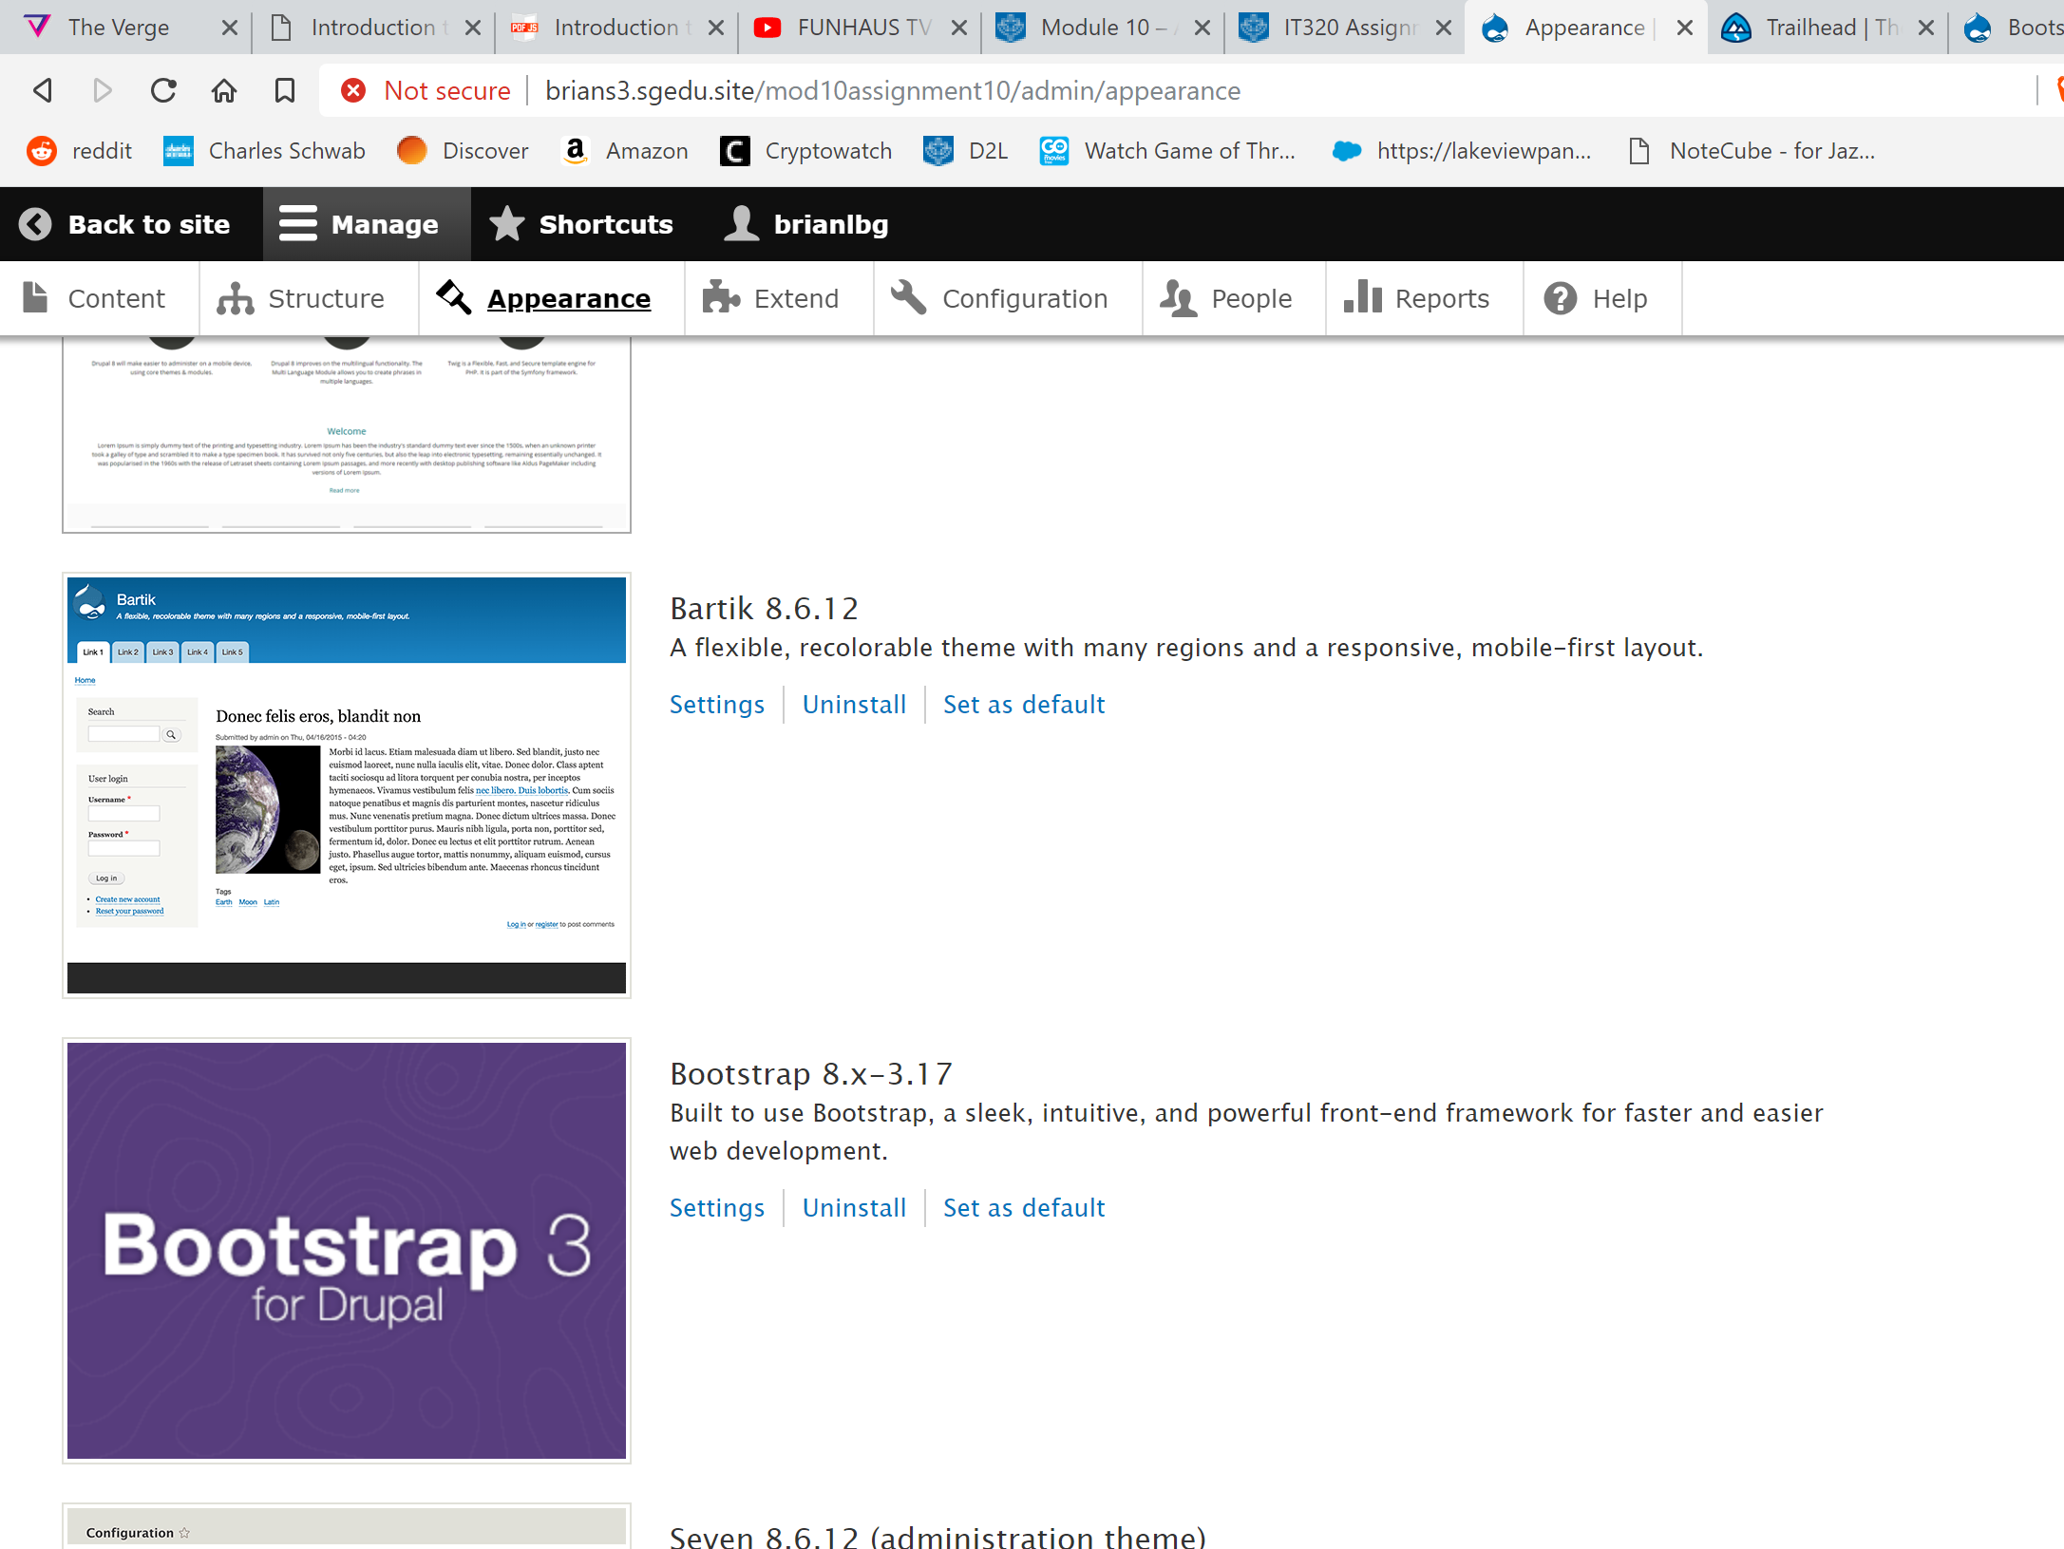 [D03]

Part E – Drupal 8 – basic pages

1. SCREEN CAPTURE – Backend List of Basic Page nodes you created  
   Admin toolbar > Content, Filter content by Basic page before taking screen capture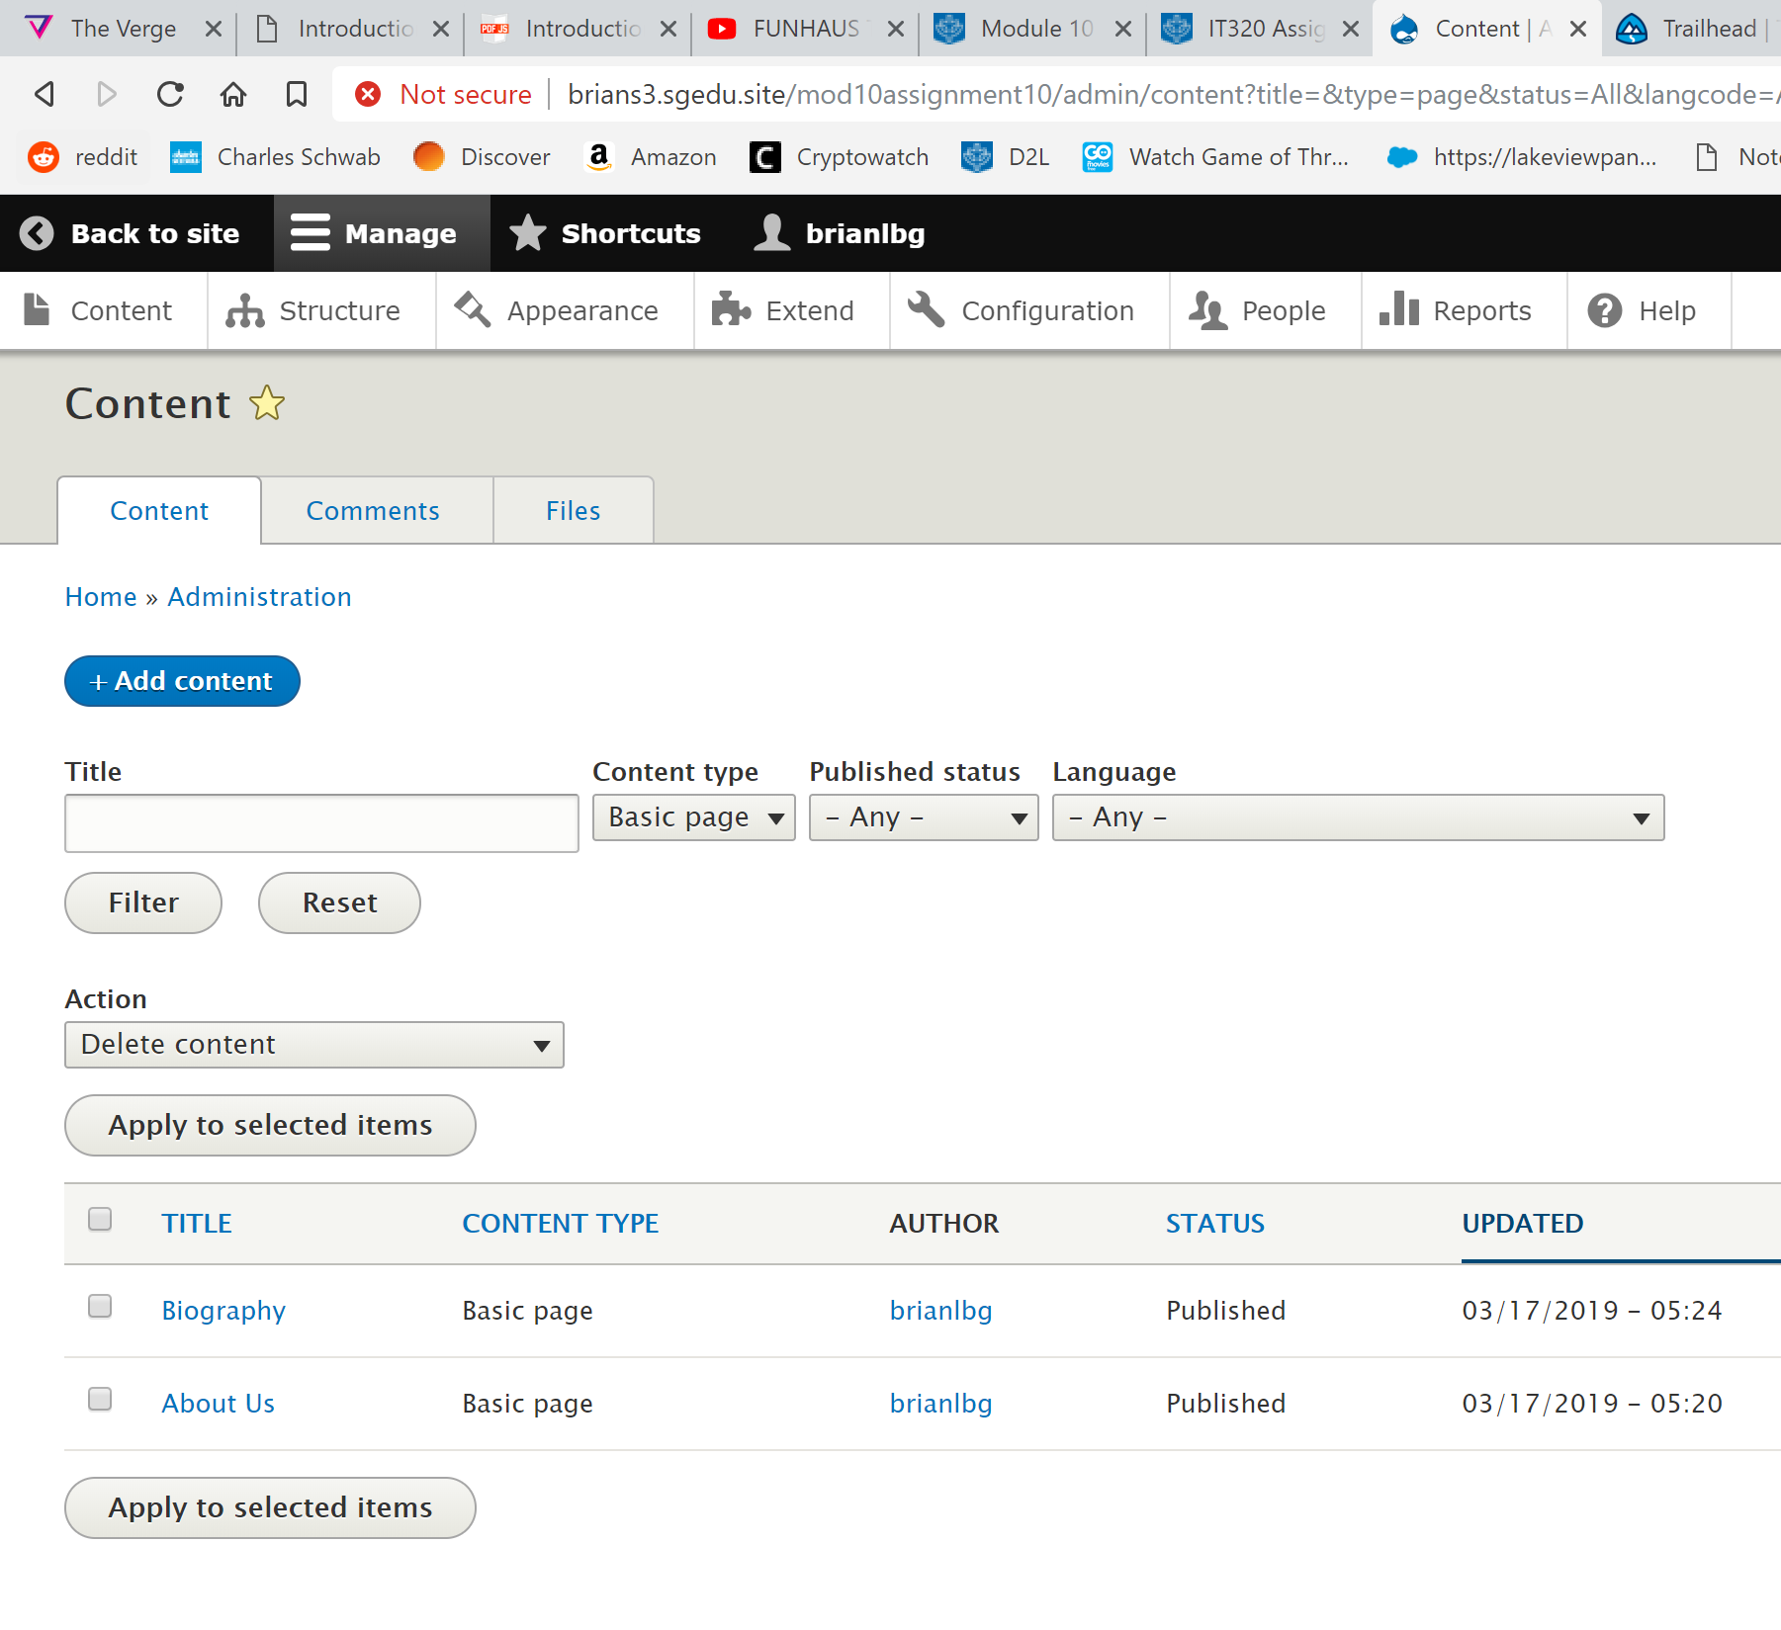 [E01]
2. SCREEN CAPTURE – Frontend screen capture of the About us page.  
   Note: Frontend means a web browser where you are not logged into the Drupal site.  
   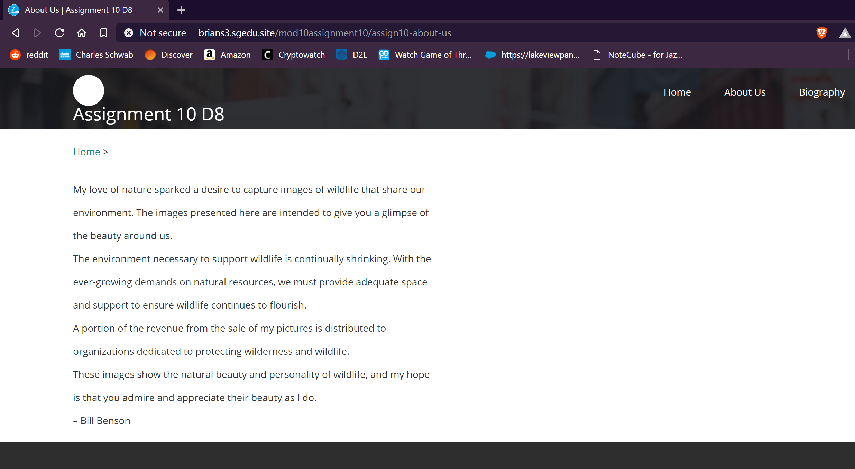 [E02]
3. SCREEN CAPTURE – Frontend screen capture of the Biography page.  
   Note: Frontend means a web browser where you are not logged into the Drupal site.  
   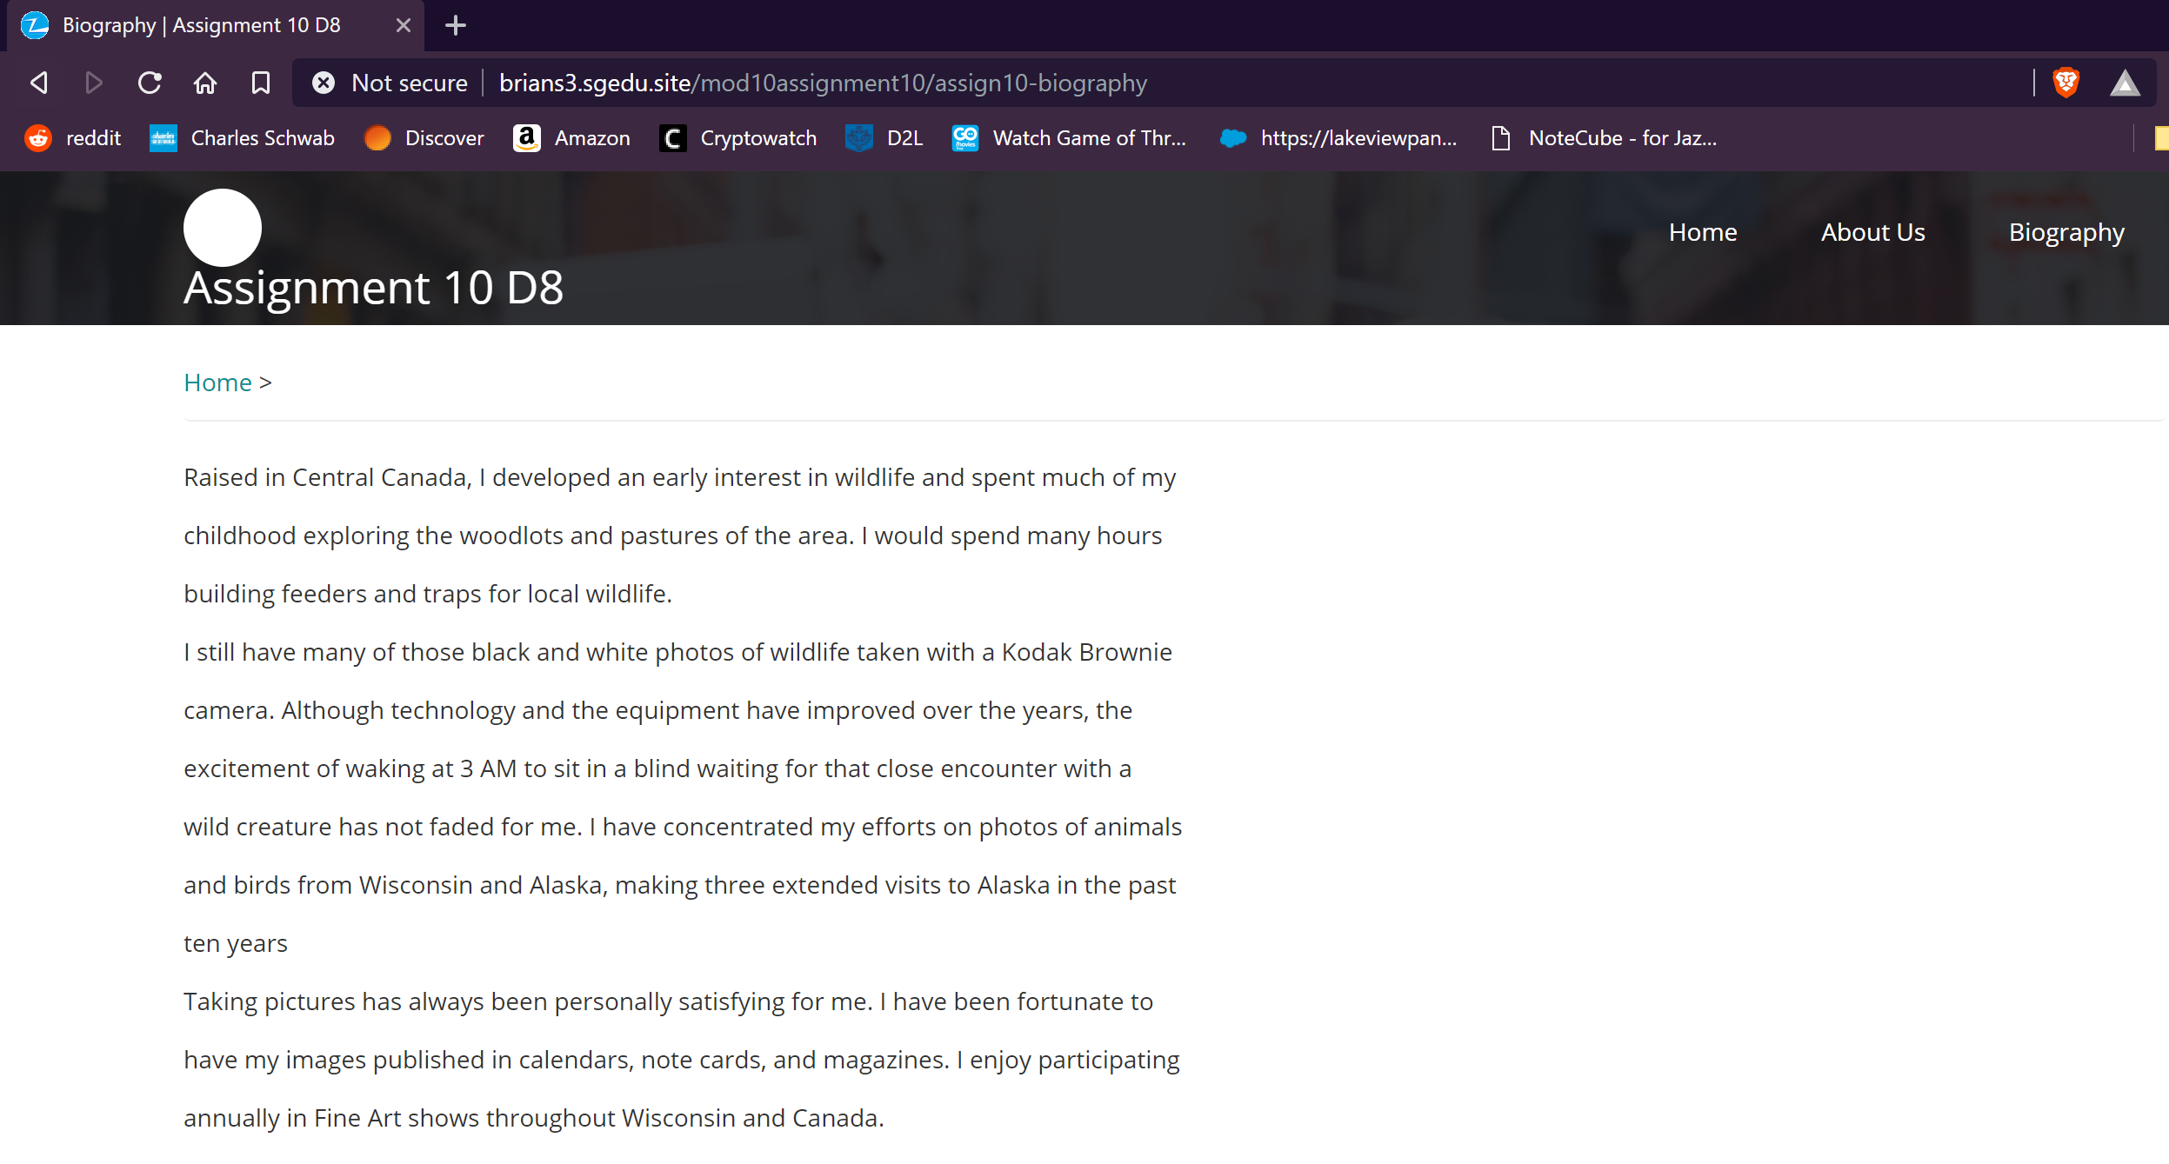 [E03]
4. Go back to the instructions and continue with Part F.

Part F – Drupal 8 Site Article:

1. SCREEN CAPTURE – Backend List of Article nodes you created  
   Admin toolbar > Content, Filter content by Article before taking screen capture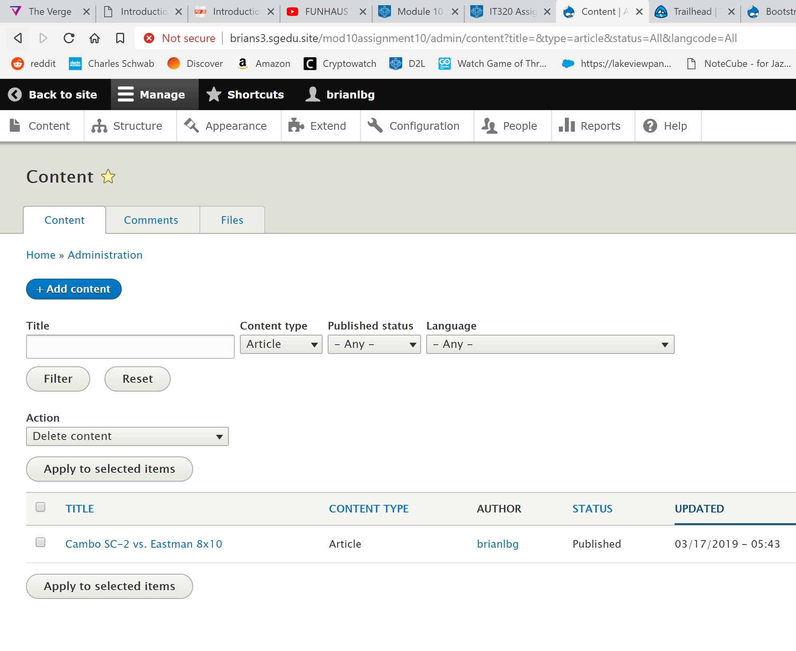 [F01]
2. SCREEN CAPTURE – Backend Article nodes Title and Tags  
   Edit an Article you created and take a screen capture the top title, tags 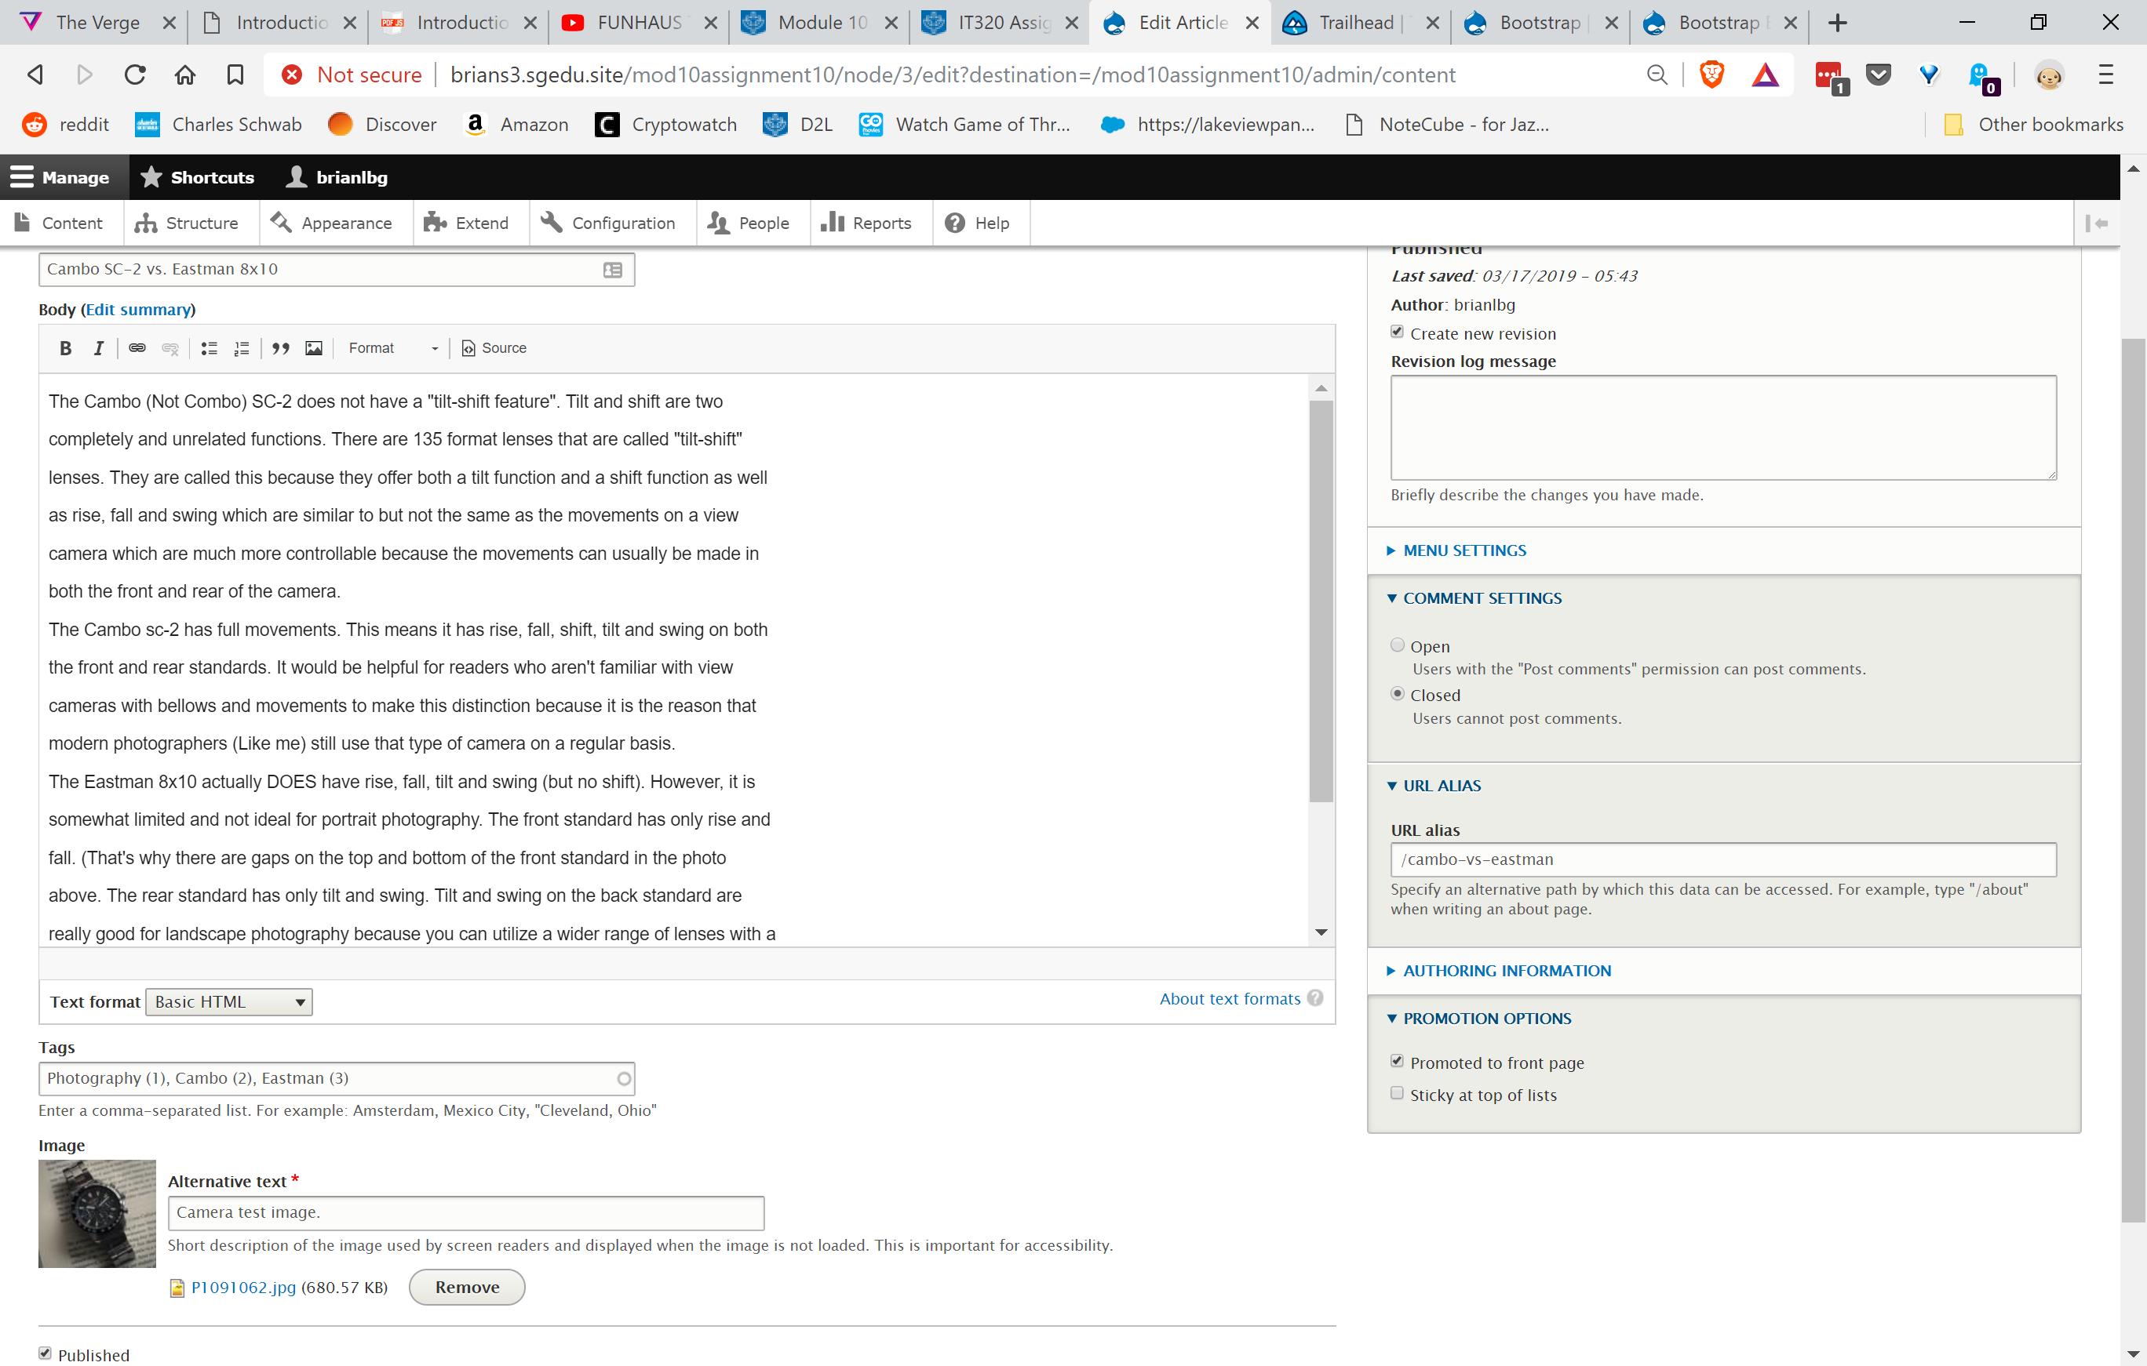 [F02]
3. SCREEN CAPTURE – Backend Article nodes Body and Blocks  
   Edit the Article you created and take a screen capture the body and side blocks   
   Show (1-9) see image below:  
   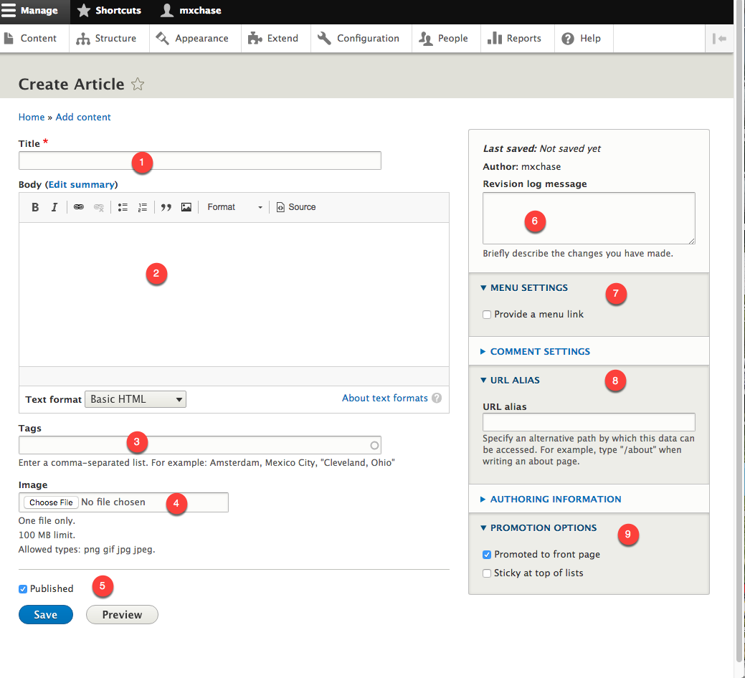   
   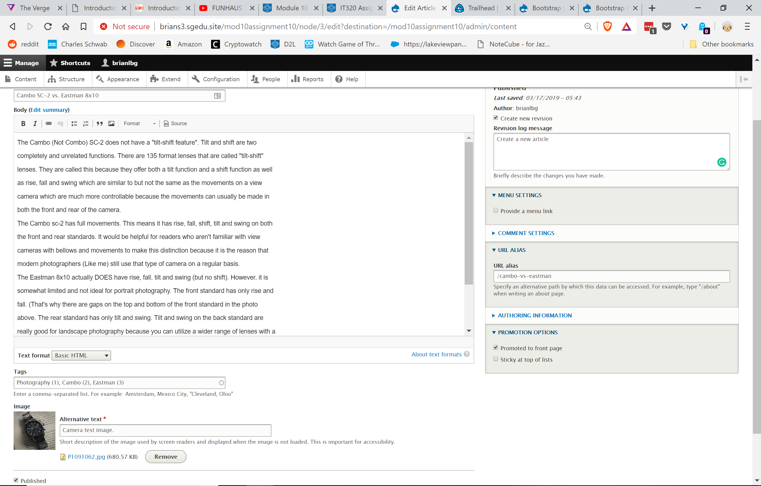 [H03]
4. SCREEN CAPTURE – Front end Article   
   Note: Frontend means a web browser where you are not logged into the Drupal site.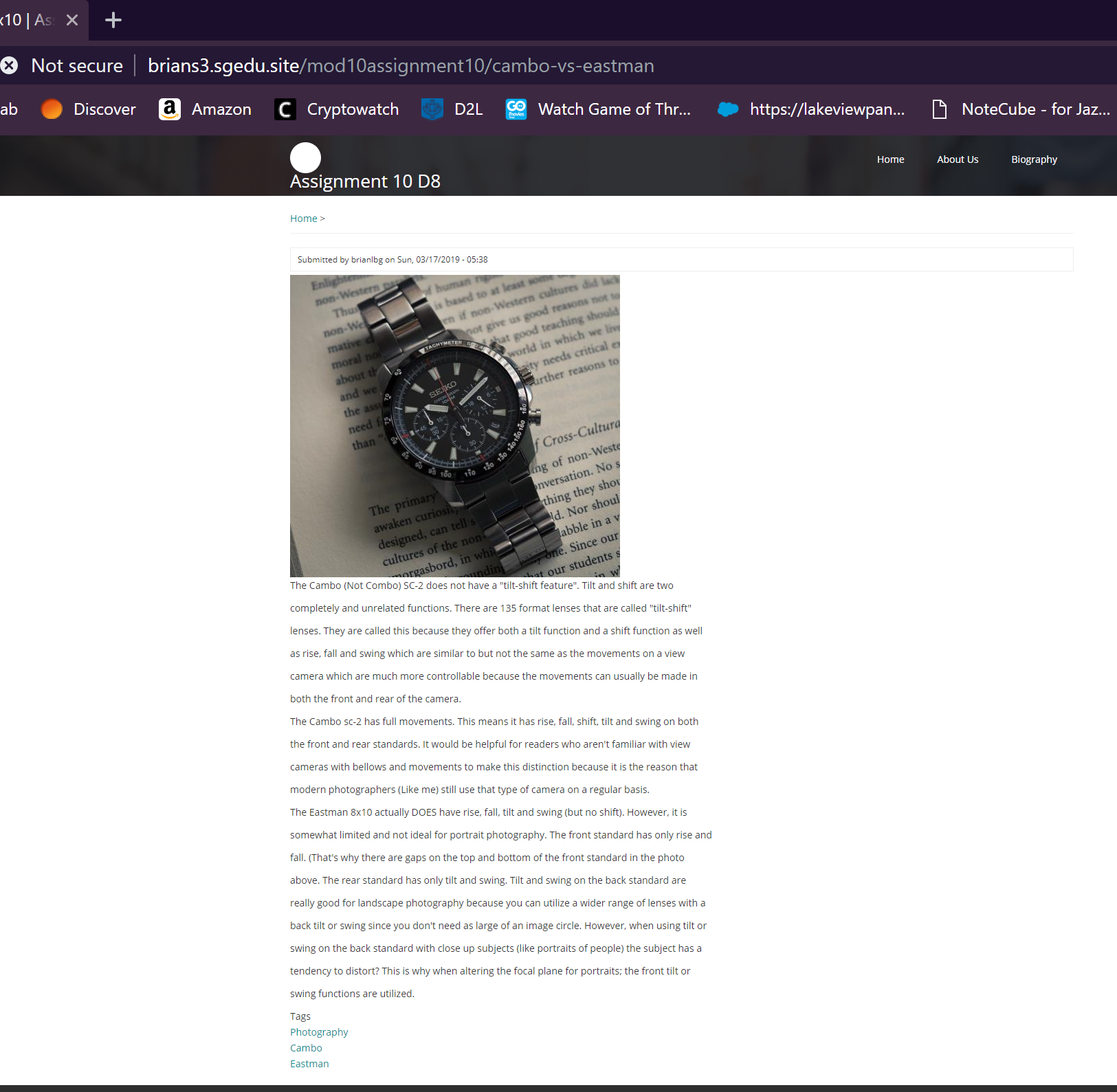 [H04]
5. Go back to the instructions and continue with Part G.

Part G – **Taxonomy-Vocabulary-Terms**:

1. SCREEN CAPTURE – Backend screen capture of the Structure > Taxonomy page  
   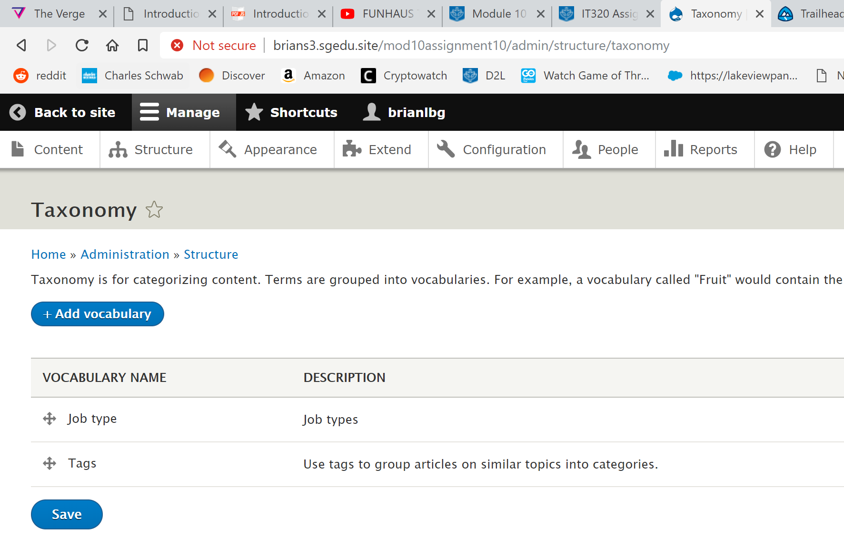 [G01]
2. SCREEN CAPTURE – List Terms page for the Job type vocabulary  
   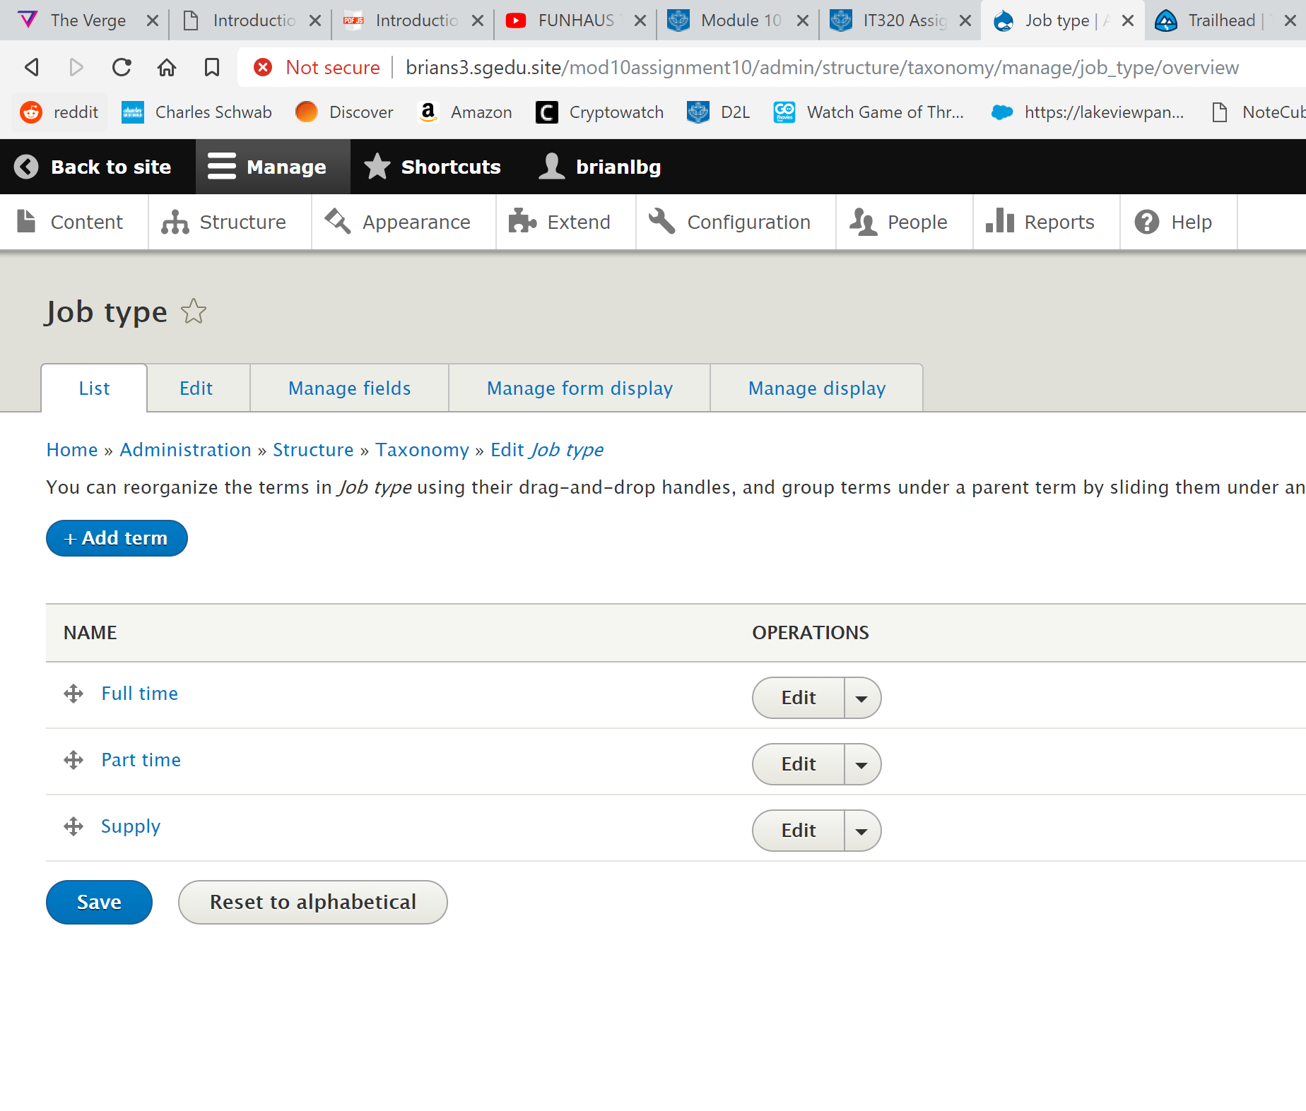 [G02]

Go back to the instructions and continue with Part H.

Part H – Extend Drupal 8 with an existing field

1. SCREEN CAPTURE – Backend screen capture of the Extend page, showing the Telephone field enabled  
   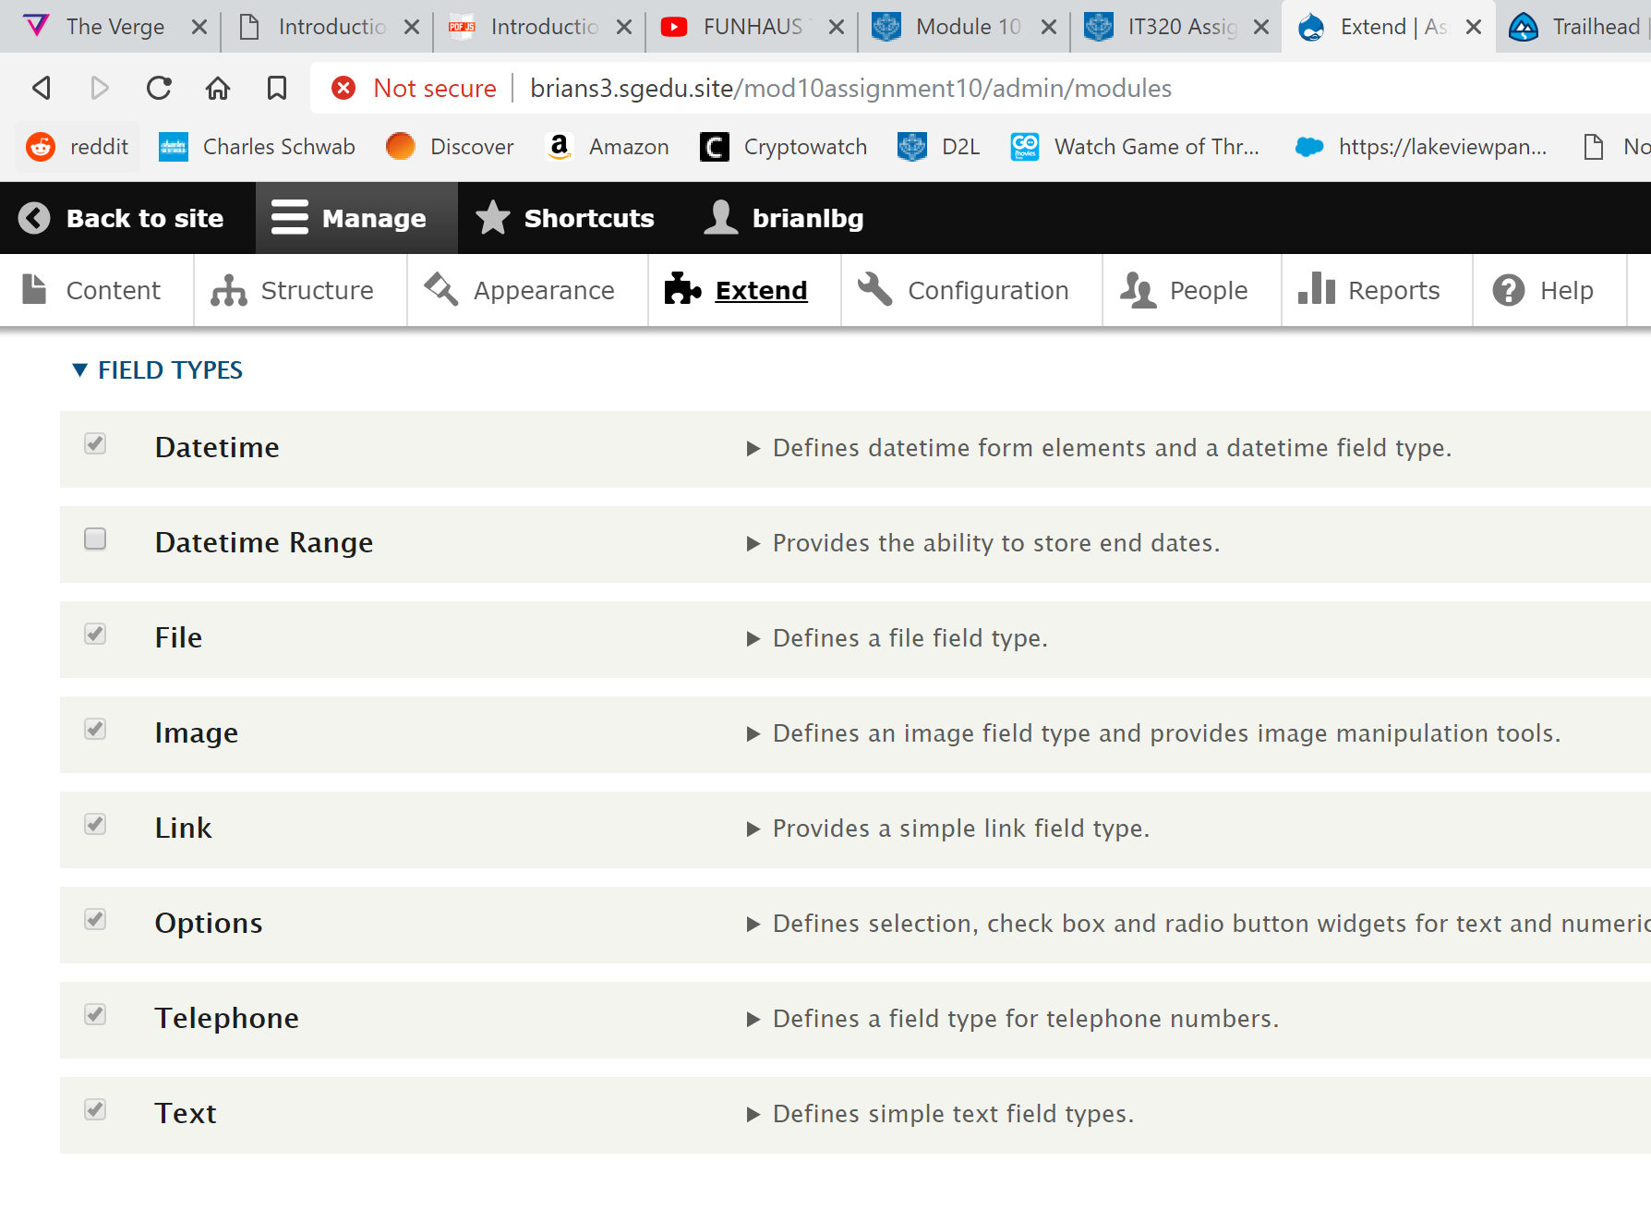 [H01]

Go back to the instructions and continue with Part I.

**Part I- Extend Drupal 8 with a Jobs custom content type**

1. SCREEN CAPTURE – Backend screen capture of the Structure > Content types, select Jobs content type Extend page, showing the Telephone field enabled  
   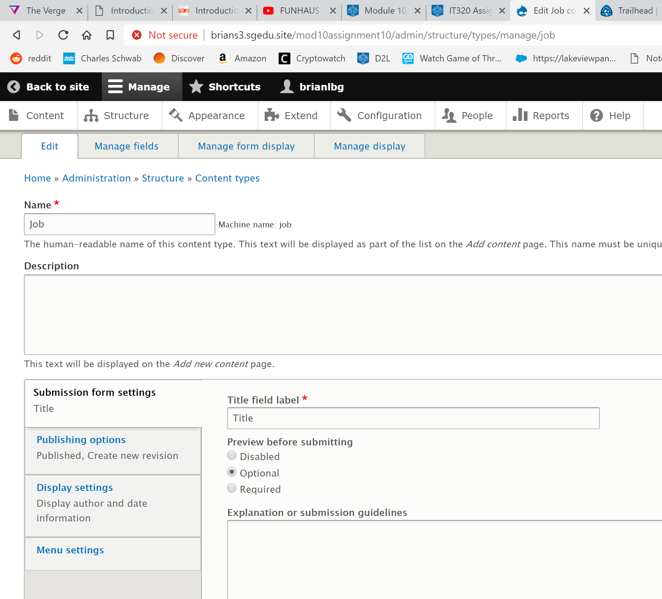 [J01.1]

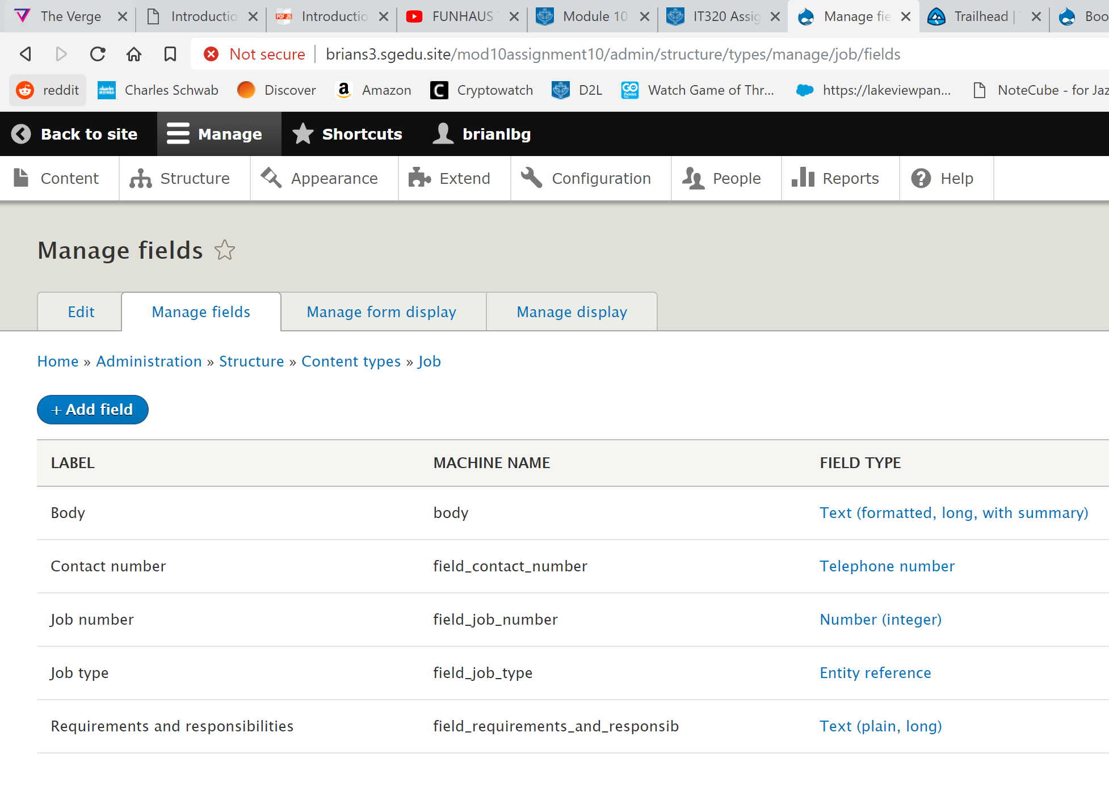 [J01.2]  
Do not submit Manage Form Display

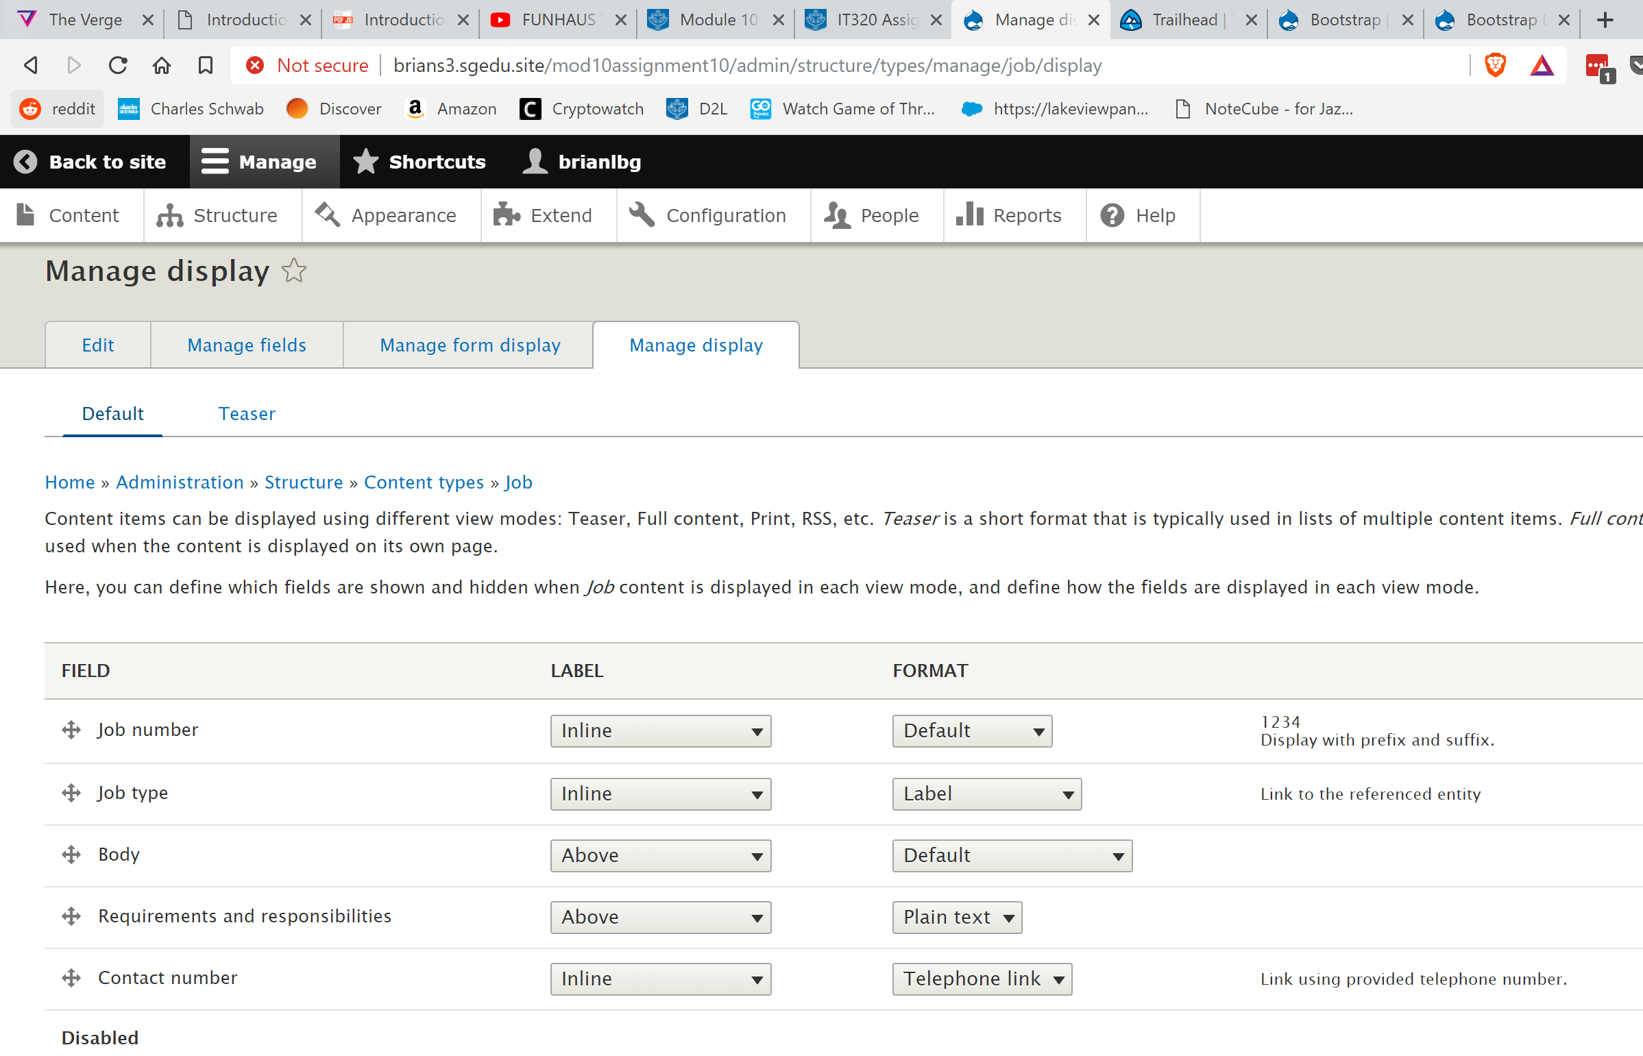 [J01.3]

Go back to the instructions and continue with Part J.

**Part J – Extend Drupal 8 add three (3) Job Nodes**

1. SCREEN CAPTURE – Backend screen capture of the Content page filter Content type by Job nodes

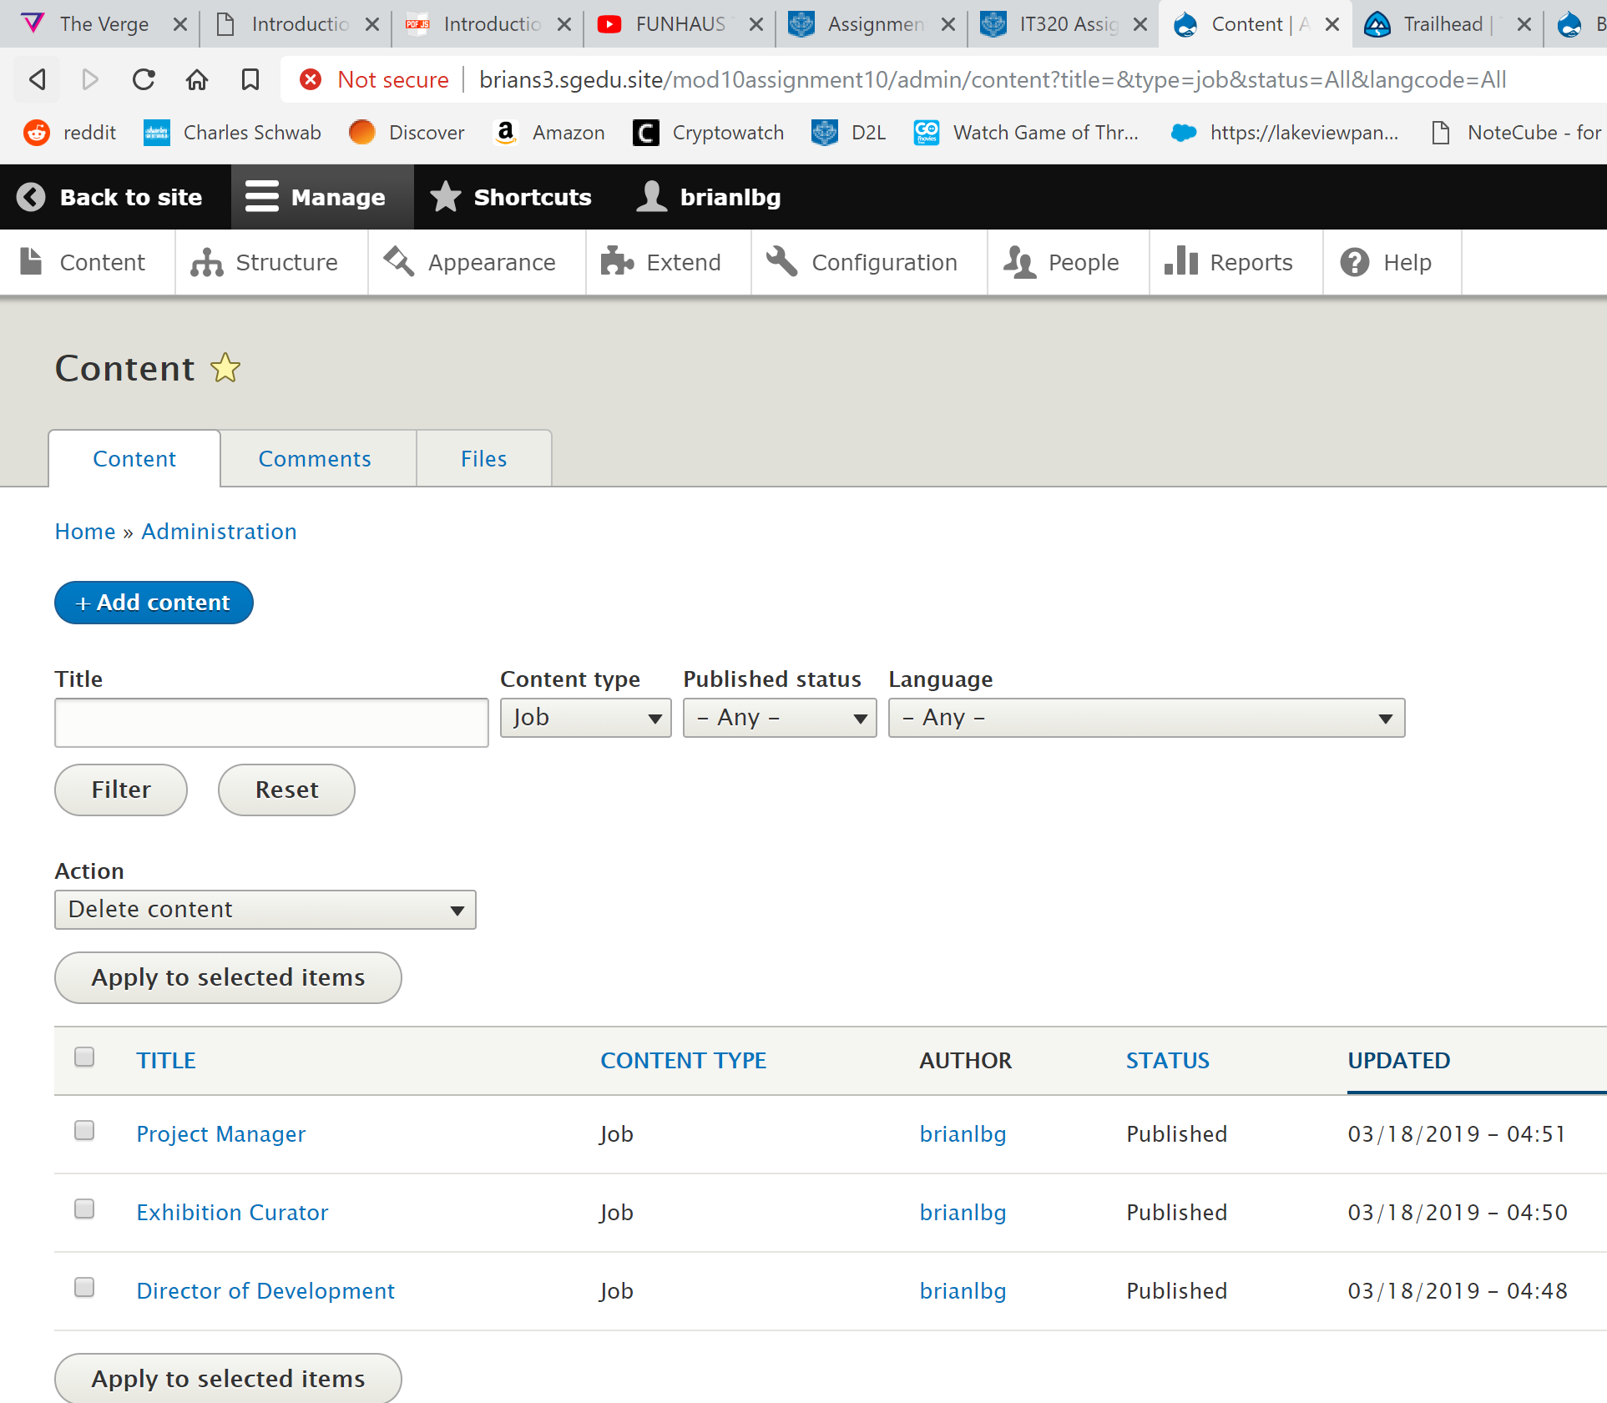 [J02]

Go back to the instructions and continue with Part K.

**Part K – Jobs View**

1. SCREEN CAPTURE – Backend screen capture of the Structure > Views showing the Jobs view in the views list  
   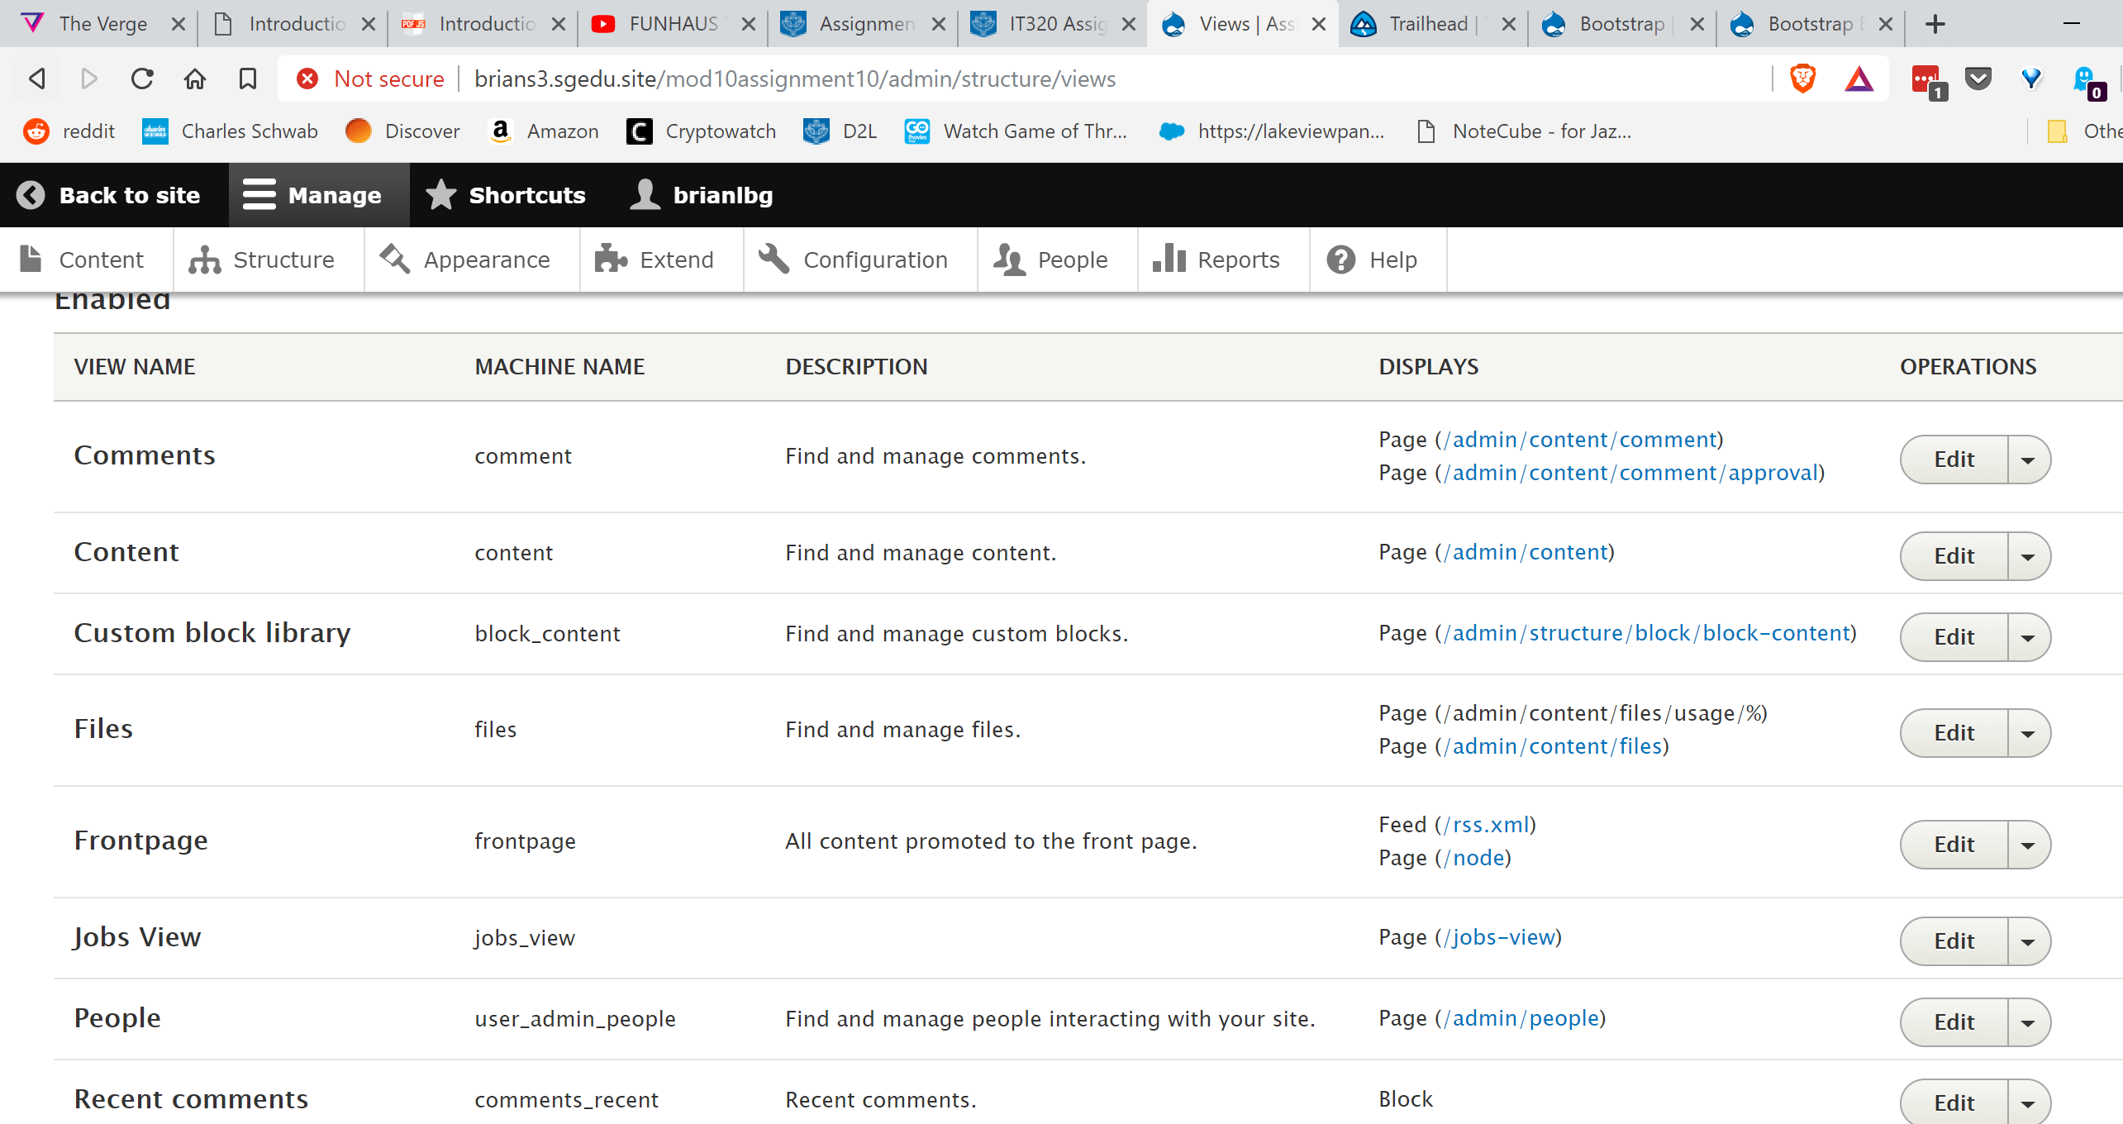 [K01]
2. SCREEN CAPTURE – Select the jobs view and take a screen capture of it. This may take more than one screen capture to show the whole view page

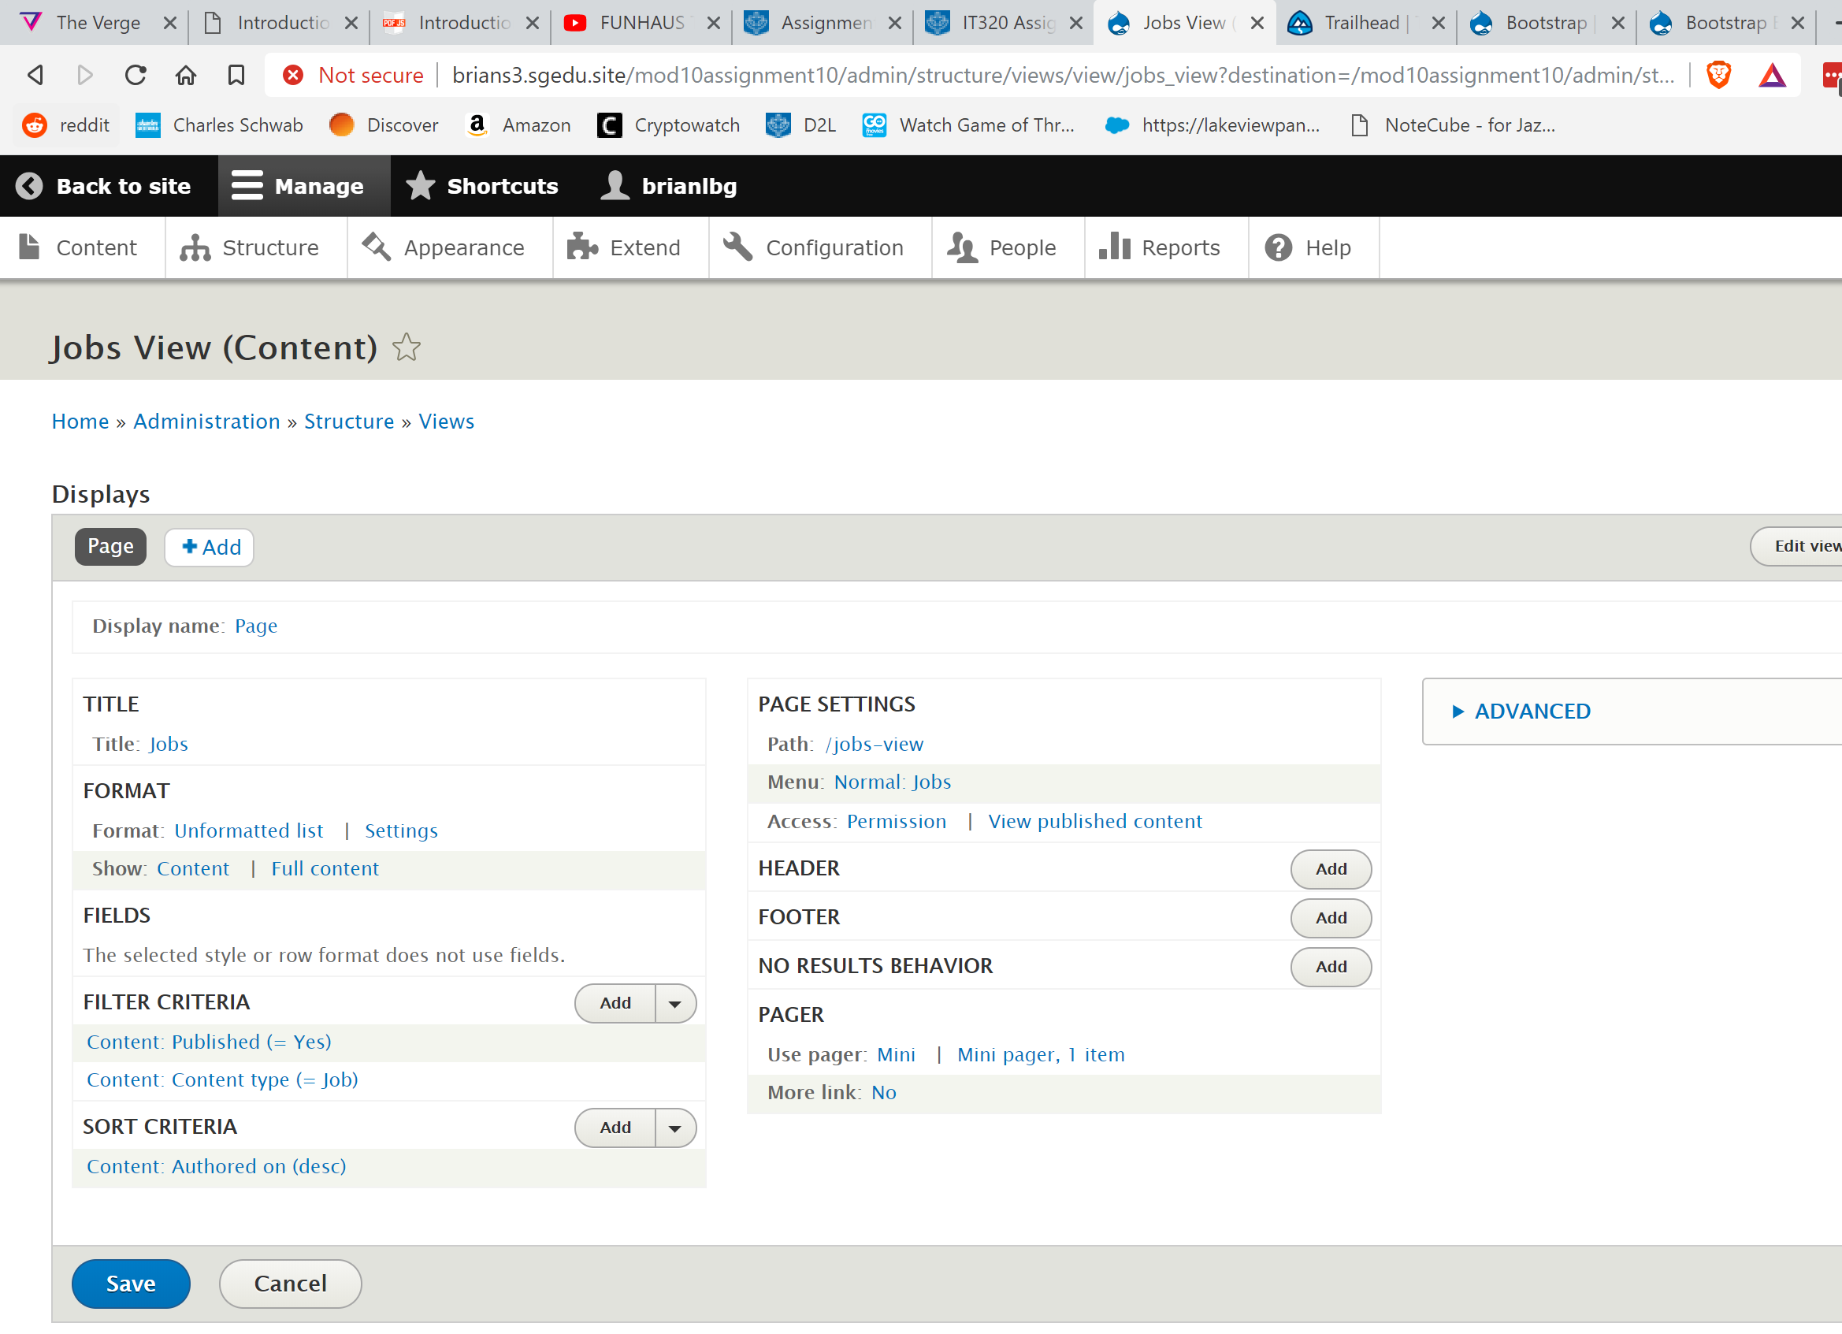 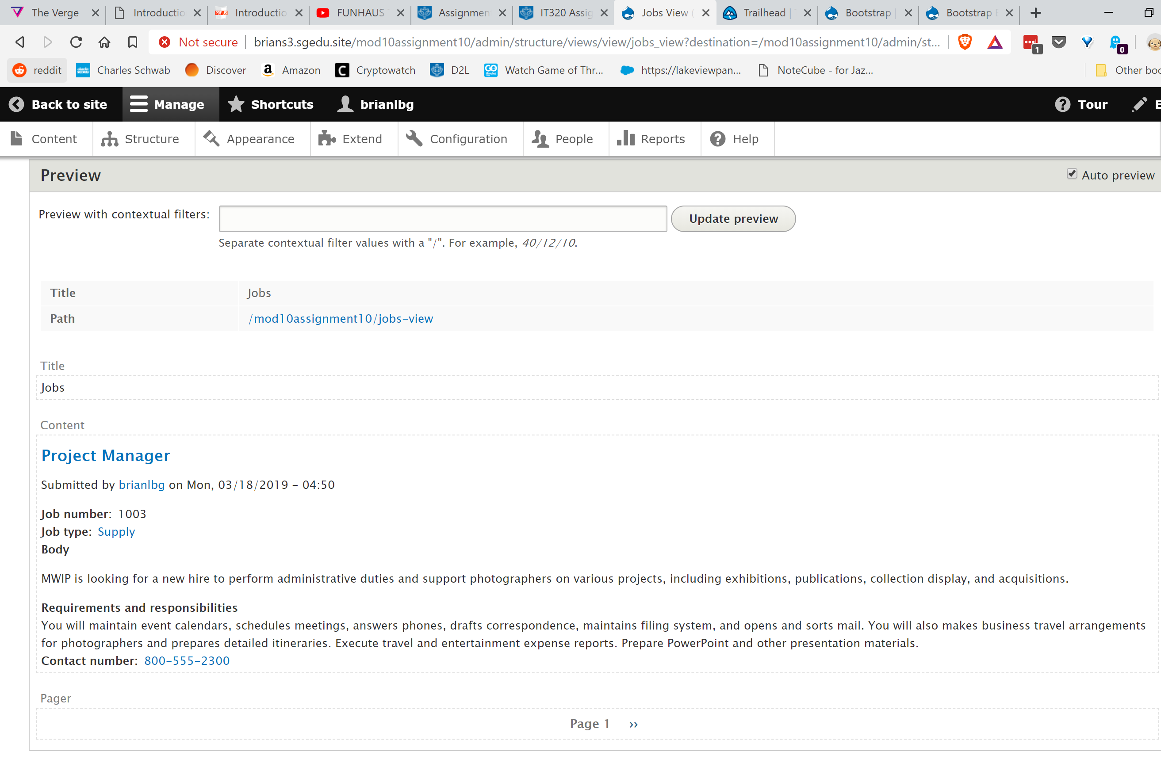 [K02]

1. SCREEN CAPTURE – Front-end screen capture of the view page showing the web browser address bar and the Jobs menu item.

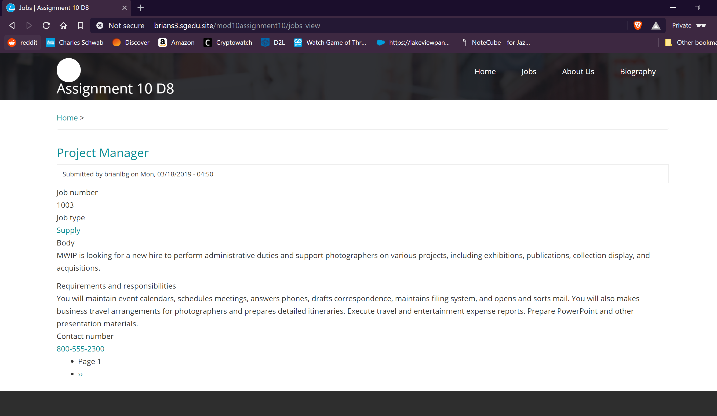 [K03]

Go back to the instructions and continue with Part L.

Part L - Create a Responsive Slideshow:

1. What is the name of the custom content type you created for the slides?  
   Responsive Slideshow [L01]
2. How many nodes of your custom content type did you create?  
   5 [L02]
3. What is the name of your slideshow view?  
   Responsive Slideshow [L03]
4. SCREEN CAPTURE – back-end screen capture of content, filter listing by your slides custom content type.

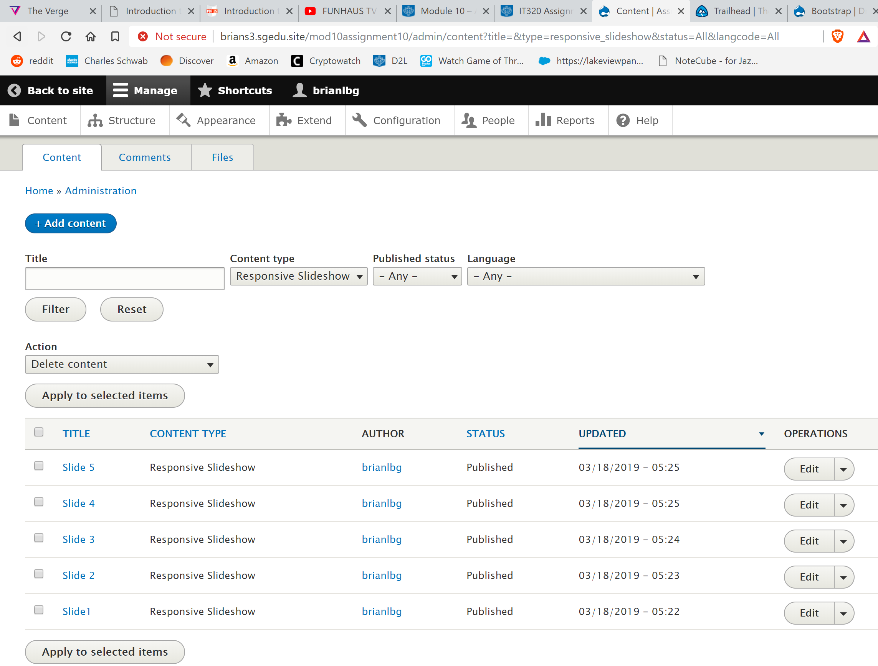 [L04]

1. SCREEN CAPTURE – Front-end screen capture of the front page showing a working slide show.

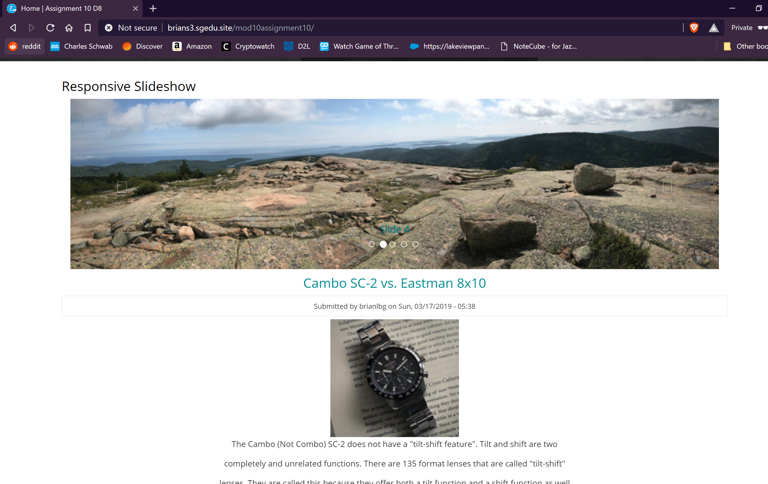 [L05]

Go back to the instructions and continue with Part M.